Geometry: Unit 1, Lesson 5
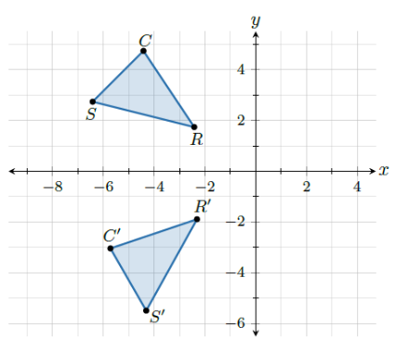
- Triangle $RSC$ is shown after a rotation, mapping to triangle $R'S'C'$ on the coordinate plane. The image is the triangle $RSC$ after what?

75° counterclockwise rotation about the origin

- A rotation is shown. How many degrees does the triangle get rotated?
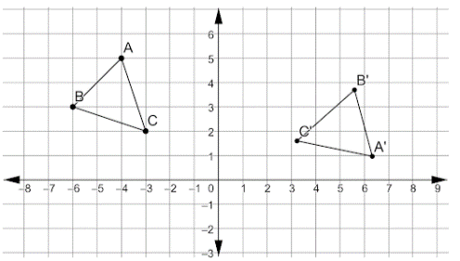

120° clockwise rotation

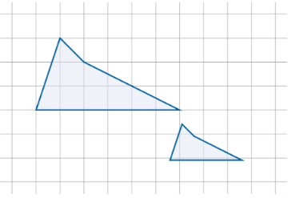
- What type of transformation is given in the example?

Dilation

